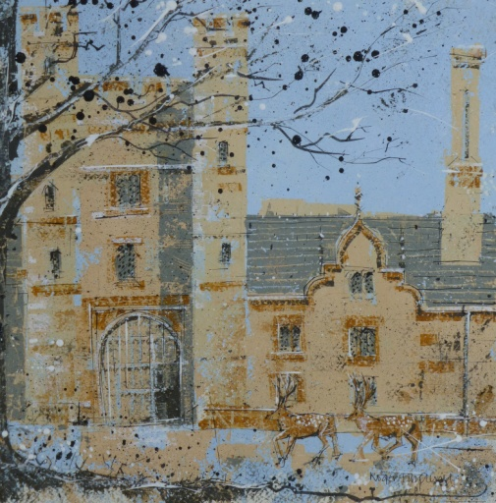

Knole House, Gatehouse

Original, acrylic and ink, 300mm x 300mm.

Mounted and framed (overall 520mm x 520mm).

£200.

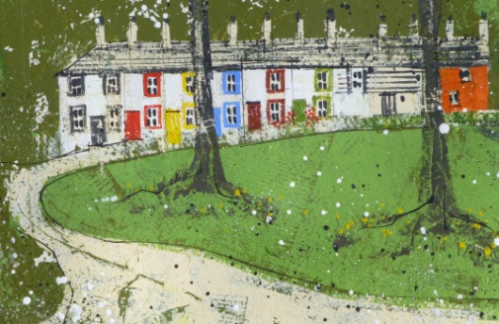

Bessels Green

Detail from original, acrylic and ink, 300mm x 300mm.

Mounted and framed (overall 520mm x 520mm).

£200.

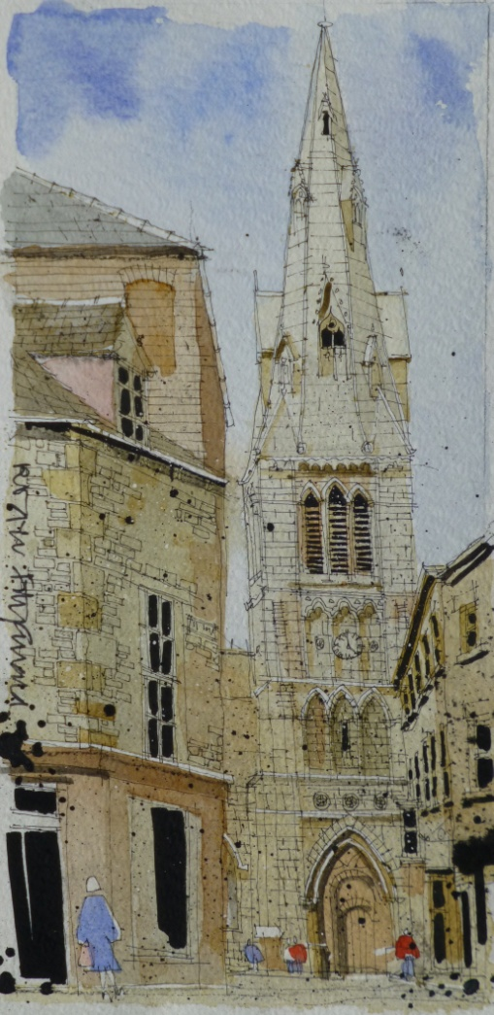

Stamford

Original watercolour and ink from Roger’s book “Buildings of Britain” (publisher: Bloomsbury), 280mm x 130mm.

Individually priced, unframed, typically £25.

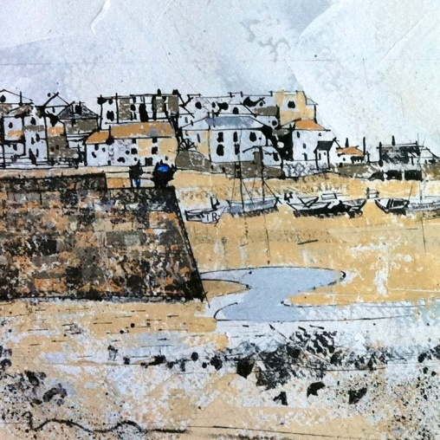

St Ives, Cornwall

Original, acrylic and ink, 1500mm x 190mm.

Mounted and framed (overall 1660mm x 360mm).

£380.